FRYEBURG BUSINESS ASSOCIATION
Board of Directors Meeting
May 18, 2016, 6 pm
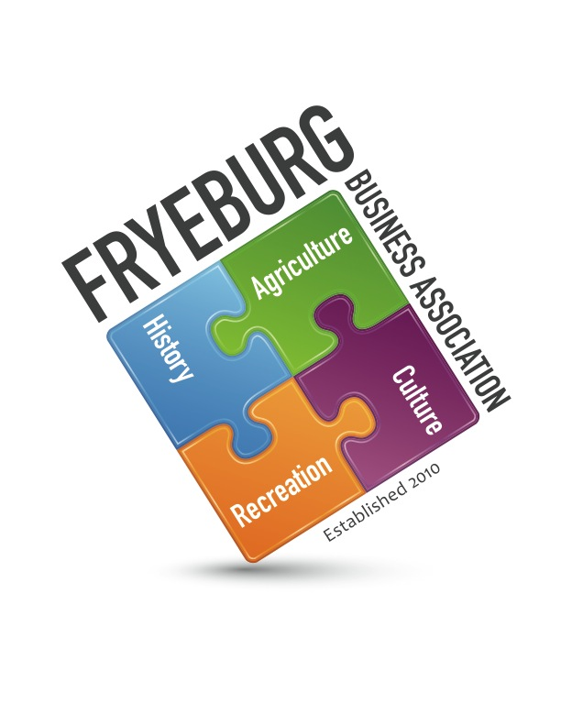
Admiral Peary Inn Bed & Breakfast

MINUTES

- The meeting was called to order at 6:06 pm.
- With a motion from DP, seconded by KC, and a unanimous vote the agenda was adopted as written
- With a motion from DP, seconded by KC, and a unanimous vote the minutes from 3-22-2016 were approved as written.
- With a motion from DP, seconded by KC, and a unanimous vote the financials were approved as written
- President’s report – David Chaffee
  - Economic Development Committee – JC presented 3 motions that will be brought fourth to the committee on May 23.
- Administrative support – Janice Crawford
  - The quarterly meeting is cancelled and members are encouraged to attend the school board budget meeting.
  - Membership – 104 paid
- Old Business – approve guideline documents
  - Committees and officers - tabled
  - Guidelines - tabled
  - Retreat - TBD
- New Business
  - Program of Work for 2017 - tabled
  - Budget Development for 2017 – tabled
- Open
  - MWVCC contract will be extended to December 31, 2016 to enable all contracts to coincide with FBA fiscal year.
  - Caleb brought up a “magic wish list”. This will continue to be pursued and fine tuned.
- Next meeting is scheduled for 8 June 2016, 6 pm at the Admiral Peary Inn
- Meeting was adjourned at 8:14 pm
Respectfully,
//signed//
Donna M. Pearce, Secretary

