FRYEBURG BUSINESS ASSOCIATION
GENERAL MEETING
WESNESDAY, MAY 20, 2015, 5:30 pm
FRYEBURG FAIRGROUNDS MEETING ROOM
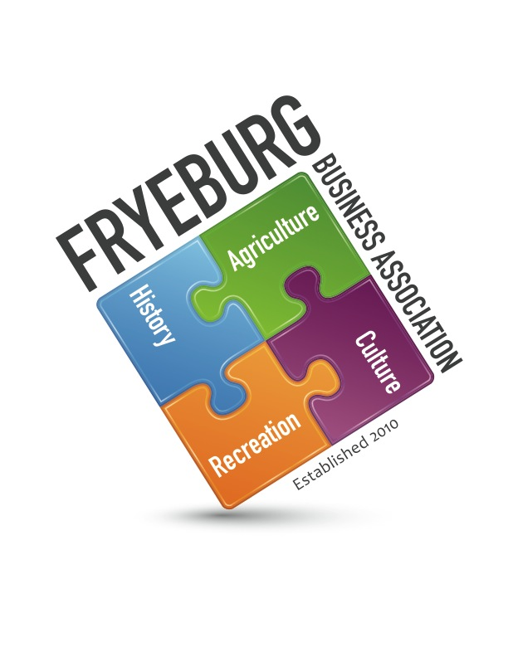
- Meeting was called to order at 5:30 pm
- Introductions were made at the end of the meeting.
- Presentation to Former President - Donna Woodward
- Agenda was adopted by unanimous vote.
- Pledge of Allegiance - Tabled
- New Business:
  - New format for meetings was explained. Wednesday nights. QUARTERLY. Meeting starts at 5:30 with a social from 5-5:30. Bring something to share if you would like for future meetings. Meetings will be timed so attendees will know what to expect. There will be a new agenda format. Meetings will follow Roberts Rules of Order to include the Pledge of Allegiance. Guest speakers will present first so they do not have to sit through the entire meeting.
  - The mission of the FBA shall be to promote and enhance a thriving business climate in the Fryeburg area.
In carrying out its mission, the object and purpose of FBA shall be to:
1. Contribute to economic vitality;
2. Encourage members to participate in community development;
3. Provide a forum for members to communicate on aspects of business;
4. Develop and encourage high standards of professionalism among association members;
5. Broaden public understanding and appreciation of Fryeburg businesses;
6. Cooperate with other organizations in the area that are aligned with the FBA mission; and
7. Undertake such functions, consistent with the mission, which advance the interest of the members
  - Bylaws revision – see attached
  - Committees procedures and expectations. This is still a work in progress. Each committee will have a BOD member. See attached list.
  - Operational guidelines – work in progress.
- Minutes from February 10, 2015 meeting were approved as written with no discussion.
- Presentation of Financials: Period ending May 30, 2015.
- Ongoing Business: Committee chairs updates:
  - Bradley park series: Nancy Ray presented the line up of the shows coming to Bradley Park. Dates are July 7 with Kids Concert, 14 with Beatle Tribute group, 21 Shark Martini, 28 Mill Town Road Show. In case of rain, the concerts will take place in the fire barn. The Write Stuff is making posters to advertise the events. The treasurer was given invoices so checks can be ready on night of the concert.
  - Piggy Bank – Sunshine Backpack Program. $1000 was presented to Chris Gillespie on behalf of the FBA by Hannafords. Chris will be invited to speak and answer any questions about child eligibility, budget, etc. Bea’s mentioned they have buying power with Sysco and would be more than happy to help offset some costs by gaining deeper discounts.
  - Website. Lots of items need to be corrected and numerous non-renewals need to be deleted from website. BOD is scheduling a meeting with MWVCC to discuss the chamber administratively working with the FBA. Krack media has been in conversation with David Chaffee for a service contract.
  - Membership Committee – 26 non-renewals. Need to ascertain reasons for not renewing. There are new businesses in town that need to be approached.
  - TOWN OF FRYEBURG Economic Development Committee. Newly formed committee with Nancy Kieman – Chair. David Chaffee – Secretary. Donna Woodward, Selectmen and Sharon Jackson as members. Sharon Jackson is a nonvoting member. The next meeting is June 29th to discuss their mission. Much discussion was brought forth in reference to this committee NOT wanting an FBA presence. More clarity is needed.
- Communications
  - Mount Washington Valley Chamber of Commerce – Janice Crawford updated the group about upcoming events in the Mount Washington Valley. She also ensured members were aware that just because you are a member of the FBA and the FBA is a member of the chamber does NOT mean FBA member is a member of the chamber. There is a job opening at chamber if anyone is interested.
  - Greater Bridgton Area Chamber of Commerce – Bonnie Gould updated the group about upcoming events in Bridgton. She also ensured members were aware that just because you are a member of the FBA and the FBA is a member of the chamber does NOT mean FBA member is a member of the chamber. There is a job opening at chamber if anyone is interested.
  - FBA Comprehensive Economic Development Committee. See attached.
- Next meeting: Wednesday, September 16, 2015. 5:30 pm Fryeburg Fairgrounds conference room
- Open Forum - The Auto Club is hosting a dance (sock hop) June 6th. Tickets are $10.00 each.
- Meeting was adjourned at 7:20

Respectfully,

/signed/

Donna M. Pearce

