FRYEBURG BUSINESS ASSOCIATION
Board of Directors Meeting
July 21 2015, 4pm
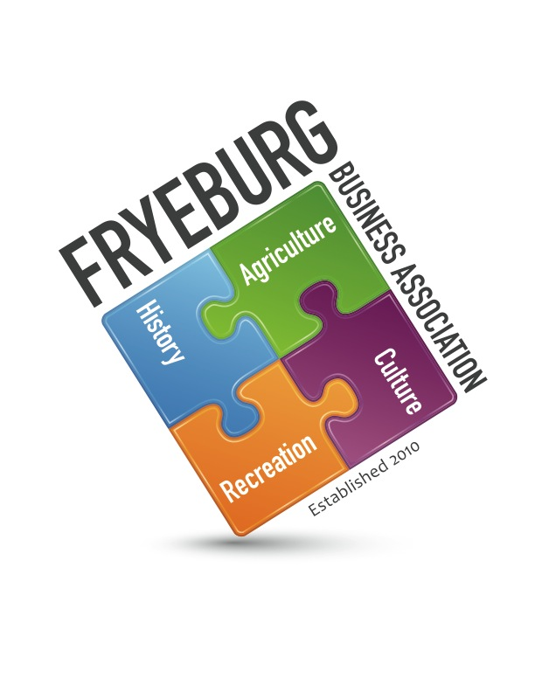
Telephone meeting

AGENDA
- Meeting was called to order at 4:20pm with Donna Pearce, Wanda Richard, Bonnie Gould, and David Chaffee present via telephone. A quorum was met with all executive board members present.
- On a motion of WR, seconded by BG and unanimous vote, the agenda was adopted as written
- Unanimously approved to delete the phone number on the website for the FBA. Motioned by BG, seconded by DP.
- Hiring MWVCC as our administrative support was approved by a majority vote. Motion by DP, seconded by WR.
- Meeting was adjourned at 5:23 pm
Respectfully,
//signed//
Donna M. Pearce

