FRYEBURG BUSINESS ASSOCIATION
Board of Directors Meeting Minutes
July 15 2015, 6 pm
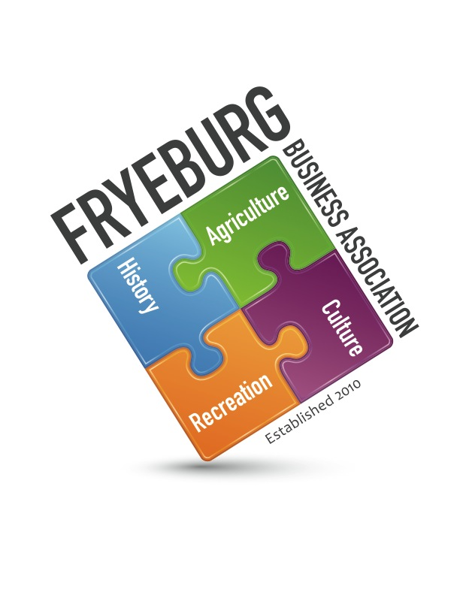
Admiral Peary Inn Bed & Breakfast

- The meeting was called order at 5:55 pm. Present were Donna Pearce, Wanda Richard, David Chaffee, and via telephone Bonnie Gould. With all members present was quorum was declared.
- The agenda was modified to have Krack Media discussed first; motion by WR, seconded by DC.
- Krack Media will remain as our website support; unanimous vote, motion by DP, seconded by WR
- Adopting MWVCC as administrative support. Further discussion required.
- Open forum: website updates.
- Meeting was adjourned at 7:21pm.
RESPECTFULLY,
DONNA M. PEARCE
DONNA M. PEARCE, SECRETARY

