FRYEBURG BUSINESS ASSOCIATION
Board of Directors Meeting Minutes
Wednesday, May 13, 2015, 2 – 3:30 pm
Allstate Conference Room
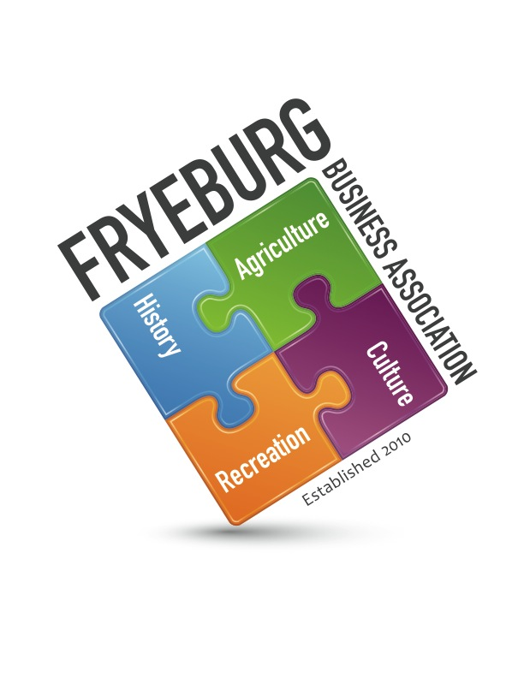

Wanda Richard Bonnie Gould (via telephone)
David Chaffee Donna Pearce

- The meeting was called to order 2:15pm.
- Adoption of agenda
- General meeting minutes of February 10, 2015 approved as written.
- BOD meeting minutes of February 22 and March 23, 2015 approved as written
- Utilizing Roberts Rules of Engagement was unanimously approved for all meetings
  - Pledge of Allegiance will be said at the beginning of all meetings
- It was decided to include the piggy bank in the charitable donations program of the FBA for 2015. It will go away through attrition. Currently we are funding the Sunshine Backpack program.
- Committees were reviewed for relevance.
  - Nancy Ray has Bradley Park concert series in hand
  - Post to FB and webpage
  - No flyers
  - No tables for local businesses
  - Bonnie to provide budget and have checks available for performers
  - Nancy will MC all nights except first. Wanda to do.
- Web update
  - David will contact Erik from Krack Media to investigate the cost of a service contract.
  - Phone number on the webpage has been changed to Bonnie Gould’s private number.
  - David will contact Mike Corthrell in reference to FBA’s Facebook page. Inquire if he is still interested in maintaining and posting to it on a regular basis. Otherwise, we need permissions and a point of contact.
  - All documents will be posted to FB and webpage.
- General Meeting agenda, social hour, and meeting content reviewed.
  - Board will meet prior to meeting at 4:30 to readiness
  - Meeting has been change to Wednesday at 5:30 preceded by a social time from 5:00 to 5:30.
  - See agenda.
  - Documents will be handed to members during the meeting at time of discussion: agenda, February meeting minutes, financial report, Simplified Roberts Rules of Engagement, bylaws, committee list, procedures.

- Meeting was adjourned at 3:35 pm.
Respectfully,
/s/ Donna M. Pearce
Donna M. Pearce, Secretary

