FRYEBURG BUSINESS ASSOCIATION
Board of Directors Meeting
Tuesday, February 3, 2015, 3:30pm
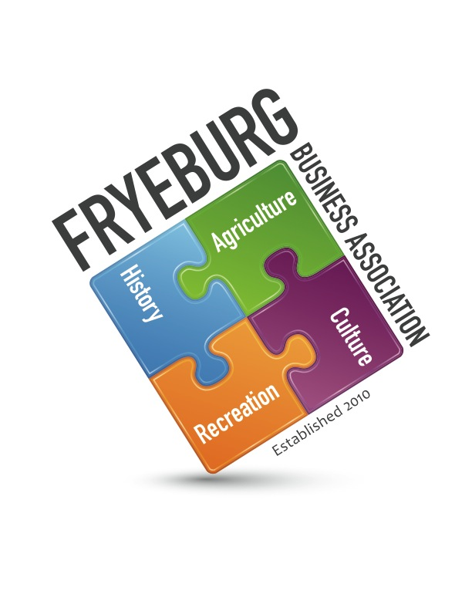
Admiral Peary Inn B & B

Wanda Richard Donna Pearce Bonnie Gould
Guests: Holly Foster, Prudy Westerberg

- The meeting was called to Order and a Quorum declared at 4:10pm.
- Previous general meeting minutes approved as written. Previous BOD meeting minutes approved as written.
- Treasurer Report – Bonnie Gould.
  - As of today, there is $13,797.13. An additional $105 in membership dues is un-deposited. There is a $50 check to MWVEC is outstanding. Milford fund approved a donation of $1200.00 for Bradley concert series.
  - Piggybank has $28 and some change.
    - A check will be written to New Suncooks PTA.
    - One piggy bank will be brought to meetings for continued contributions.
    - It was decided to declare a Piggy Bank Cause of the Year at the beginning of the year so meeting attendees will know where their contributions are going.
    - A charitable contribution box will be included on all future invoices.
  - The quick-books program has been reinstalled on Bonnie Gould’s computer however the program needs to be customized to FBA
  - Quick-Books invoicing has not been done. Changes next year to invoices will reflect charitable contributions.
- Membership Update
  - Combined update from Bonnie Gould and Holly Foster. There have been 70 renewals as of February 3, 2015.
  - The BOD and guests divided remaining members who have not renewed up. Each BOB member will contact these members personally.
- Web Update – report tabled. However,
  - Needs updating to reflect changes in Board of Directors and their resumes
  - Needs updating to reflect changes in membership
- Business/Student Mentoring Program – Wanda Richard
  - Deb Delmonico, Guidance Counselor, Molly Ockett Middle School, has started. Wanda will schedule an appointment to see what potential needs and desires the FBA can facilitate.
- Economic Development
  - Meeting notes were send December 1, 2014. Future meetings have not been scheduled. Meeting information needs to be analyzed to determined next steps.
- Mission Statement reviewed – tabled. However, the FBA has a problem. Businesses feel like they NEED to join but do not know what the FBA does for them. Meeting attendance has declined. A questionnaire will be send to the membership via email and USPS to see why people are not attending meetings. i.e., weather, inconvenient day and/or time. The questionnaire will also ask what the membership would like as added value. i.e., group health insurance (?) for small business, community involvement. Is the FBA focusing on the wrong issues for the businesses. We must remember this is not personal. It is a hard reality.
- Bylaws: as a follow-up
  - The verbiage for declaring a quorum during a BOD meeting has been changed to “A quorum of three Board members is required for the conducting of business. “
  - The verbiage for declaring a quorum has been changed to “majority vote of the members present at any given meeting”.
- Guest speakers. We have not had good attendance at the general meetings. The BOD decided it would be not in the FBA’s best interest to invite a guest speaker. It would not be worth the guests’ time and effort and would be an embarrassment to the FBA.
  - Criteria – tabled.
  - Requests
    - March Meeting: Scott from Memorial Hospital - The Future of Healthcare in Our Community – What it will mean for you, your business and your employees. Approved.
    - April Meeting: Mark Dubois from Poland Spring - Assessing the community needs and wants and what Poland Spring can do to be “Good Neighbors” in Fryeburg. Approved.
- General Meeting agenda was reviewed. Approved with changes.
- Potential day and time change for meetings – tabled.
- All - see questionnaire suggestions below.
- Meeting was adjourned at 4:49 pm.
Respectfully,
/s/ Donna M. Pearce
Donna M. Pearce, Secretary

The Fryeburg Business Association is a professional business association. Our current mission statement is:
“To promote a positive business environment that contributes
to the community and economic vitality of the Fryeburg area.”

Your membership dues of $35 annually provides visibility on our new website. As members of the FBA you are member of the Mount Washington Valley Chamber of Commerce and the Greater Bridgton Chamber of Commerce.

QUESTIONAIRE:

The Board of Directors needs all members of the FBA to share their needs and desires with the BOD to further enhance the FBA values to the community. Enclosed is a Self addressed stamped envelope for your convenience. Please take a few moments and provide us with your input.
Meeting attendance has declined. Please help us determine why and how to fix it.
1. Do you come to regular scheduled general membership meetings?
YES _______________ NO_________________
Why or Why not? _______________________________________________________________
- Weather is a deterrent? YES ________ NO_______
- Not convenient day? YES ________ NO_______
What day works for you and your business___________________________________________
Not convenient time? YES _______ NO_______
What time works for you and your business__________________________________________
2. What would add value to you and your business for continued membership with the FBA?
- Group health insurance (?) for small business
- Community involvement.
- Is the FBA focusing on the wrong issues for businesses?
- Business to Business discount? Would you be willing to provide a discount to fellow FBA members? Would you be willing to sign a year-long contract and having that discount reflected on your website?

3. Guest speakers
- Do you enjoy the guest speakers
- What topics would like to hear
- What length of time should be afforded to the guest speakers for their presentation?
-
4. Do you belong to any other business associations?
-Which associations? _____________________________________________________ ________________________________________________________________________________________________________________________________________________________________________________________________________________________
-Why? What is their value to you? ________________________________________________________________________________________________________________________________________________________________________________________________________________________________________________________________________________________________
5. Do you want the Fryeburg Business Association to continue?
6. Are you satisfied with how your business is going? How can we be of assistance?

7. Are you satisfied with how the town of Fryeburg is?

