FRYEBURG BUSINESS ASSOCIATION
Board of Directors Meeting
Thursday, January 8, 2015
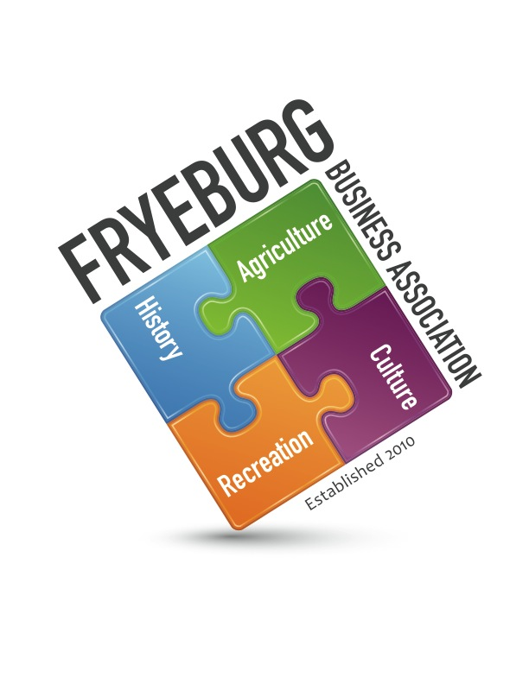
Electronically

Wanda Cox Donna Pearce Holly Foster
Bonnie Gould David Chaffee

- Call to Order/Quorum – the meeting was conducted electronically.
- Previous general meeting minutes approved with recommended changes. Previous BOD meeting minutes approved with recommended changes.
- Treasurer Report – Bonnie Gould.
  - As of today, there is $13,797.13. An additional $140 will be deposited 1/9/2015. No outstanding checks or obligations.
  - Piggybank has $20 and some change. What do we want to do with it? Anything for 2014 or just keep it going for now? It was discussed the piggybank may need to be eliminated since there have not been any contributions of late. Donna Pearce suggested we see if attendance increases this month and in the near future.
  - Mount Washington Valley Economic Council requested FBA join their group. Membership is $50.00. This was approved and a check will be sent with registration paperwork on behalf of FBA by Bonnie Gould.
  - The quick-books program has been reinstalled on Bonnie Gould’s computer however the program needs to be customized to FBA
  - Quick-Books invoicing has not been done
- Membership Update
  - Per Bonnie Gould. There have been 57 renewals as of January 8, 2015.
  - Per Holly Foster. There are 52 renewals including 2 complimentary: Fryeburg Health Care Center and West Coast Magazine. This balances with forms received including 3 without forms and 1 pay-pal. We have 117 membership plus Krack Media who has not yet joined. I suspect that Turner Publishing will not renew. I also heard that Hannaford is not going to.
  - Holly has been asked to provide an updated membership spreadsheet – DONE. The complimentary memberships are highlighted.
  - Membership invoicing was mailed to the current membership via USPS with a follow-up email reminder.
- Business/Student Mentoring Program – WC
- Economic Development
  - The MWV Economic Council has sent a request for us to become members and I feel we should all support each other and would like to suggest we become members. With that said, Jac Cuddy was called in reference to a non-profit rate for annual membership. Since we are totally a volunteer organization we could join at whatever rate we feel comfortable with. Bonnie has the membership form and will join on behalf of the FBA for $50. See IIIc.
  - Holly Foster motioned for Mike Corthrell to be removed from the Economic Development committee since he has not been a participating member.
- Mission Statement reviewed – tabled.
- Bylaws – During the past several meetings there have not been enough voting members present to declare a quorum. It has been discussed in previous meetings to change the voting members from eight to five to declare a quorum. It is now being presented to the board to change the verbiage to the “majority vote of the members present at any given meeting”.
- Guest speakers
  - Criteria – tabled.
  - Requests
    - March Meeting: Scott from Memorial Hospital - The Future of Healthcare in Our Community – What it will mean for you, your business and your employees. Approved.
    - April Meeting: Mark Dubois from Poland Spring - Assessing the community needs and wants and what Poland Spring can do to be “Good Neighbors” in Fryeburg. Approved.
- General Meeting agenda was reviewed. Approved.
- Potential day and time change for meetings – tabled.
- All
- Adjourn

Respectfully,
/s/ Donna M. Pearce
Donna M. Pearce, Secretary

3

