FRYEBURG BUSINESS ASSOCIATION
Board of Directors Meeting
December 8 2015, 6pm
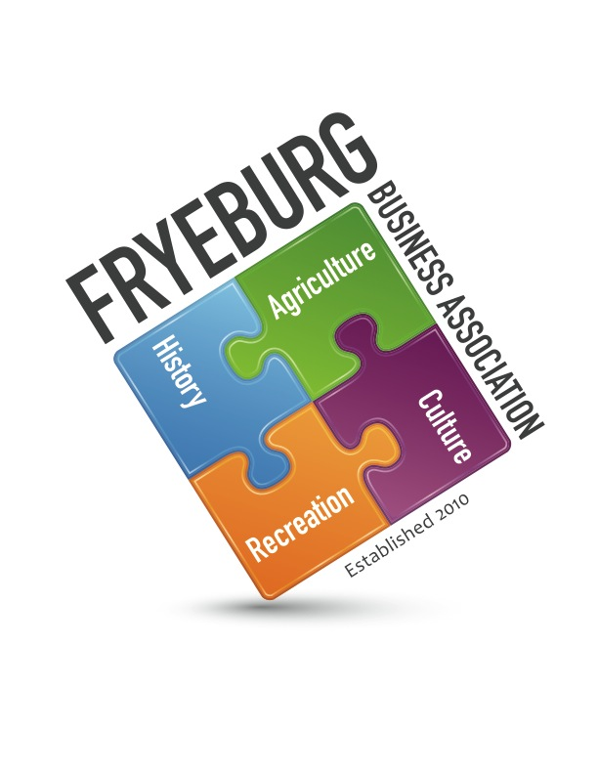
Admiral Peary Inn

Minutes

- Meeting was called to order at 6:01 pm with Donna Pearce, Wanda Richard, and David Chaffee present. A quorum was met. Janice Crawford was present.
- On a motion by DC, seconded by WR the agenda was adopted as written.
- On a motion by DC, seconded by WR the meeting minutes from September 2, 2015, and November 5, 2015, were unanimously approved as written.
- Administrative support – Janice Crawford
  - Treasurer Report from 11-30-2015 presented
  - Marketing
    - Member newsletter is due January 26, 2016. Membership renewal invoice with an increase of $5.00 in dues will be sent after Dec. 15th
  - Tourism
    - Web update – Krackmedia and DP - Continuing efforts to bring the website up to date are occurring.
    - Facebook – Mike Corthrell will continue to research business articles and post. Anyone can send information about their business to Mike for posting.
    - Reviewing the Maine State Office of Tourism, Maine Tourism Association, MWVCC and Bridgton opportunities.
    - Interface with MWVCC “What’s Your Adventure” campaign to build Spring Traffic with emphasis on developing events centered around Extreme Sports, Arts and Culture, Map and Directory, interface with Economic Development Committee
    - Map and Directory
- Old Business
  - Operational guidelines changes approved.
  - Committees – need to determine necessary committees, guidelines,.
  - Economic development - David Chaffee, as FBA representative to the Fryeburg Economic Development Council, was tasked with “asset mapping”. David will be reaching out to FBA members for assistance
  - A letter to be drafted to town and other parties extricating FBA from the Bradley Park Concert Series. The FBA will be more than happy to post schedule.
- New Business
  - BOD meetings are the forum for members to bring questions or concerns. Members must contact the current President to be placed on the agenda. BOD meetings are held at 6pm, second Tuesday of scheduled month at the Admiral Peary Inn. Anyone can attend the BOD meeting. Meeting dates TBD.
  - Signatories for the checkbook will be: President, Vice President, Treasurer. Administrator will send invoices to Treasurer for review.
  - 2016 Calendar/theme/agenda. All meetings will be held at the Laura Hill Eastman PAC at 6:30 pm (social) 7:00 pm meeting/educational forum. All meetings will have these components. Theme will be “Pride of Place”,
- Meeting was adjourned at 7:07 pm.
Respectfully,
//signed//
Donna M. Pearce

