FRYEBURG BUSINESS ASSOCIATION
Board of Directors Meeting
September 2 2015, 5pm
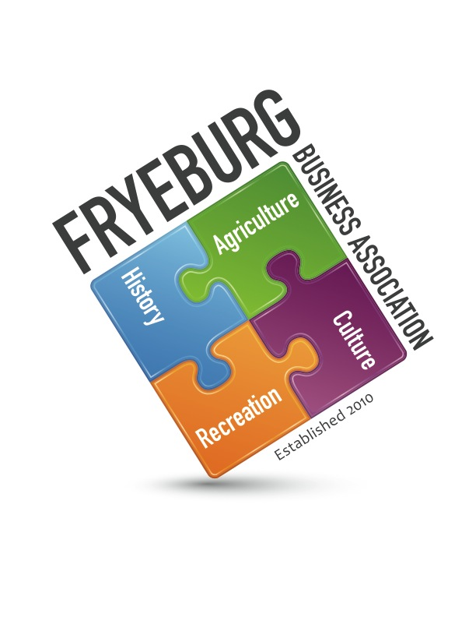
Admiral Peary Inn

- Meeting was called to order at 5:02 pm with Donna Pearce, Wanda Richard, Bonnie Gould, and David Chaffee present. A quorum was met with all executive board members present. Janice Crawford was present.
- On a motion by BG, seconded by DC the agenda was adopted as written.
- MWVCC / administrative support briefing given by Janice Crawford. No report this month.
- On a motion by DC, seconded by WR the meeting minutes from July 15, 2015, and July 21, 2015, were unanimously opposed as written; Discussion: Delete excess communication.
- Treasurer’s Report ending August 31, 2015, was presented.
- Ongoing Business:
  - Committees: procedures and expectations. Tabled for JC to develop till November BOD meeting.
- New Business:
  - Mulford Fund. Need criteria and what has been previously submitted on behalf of the FBA by Nancy Ray.
  - Police Camera. Discussed what FBA could do.
  - Need policy for posting to website and sending e-blasts.
  - Bank signatures. WR will go to Norway Bank this week
- Web update. Donna Pearce will ask members for updated information
- General meeting agenda review.
- Meeting was adjourned at 6:20pm
Respectfully,
//signed//
Donna M. Pearce

