FRYEBURG BUSINESS ASSOCIATION
Board of Directors Meeting
Tuesday, March 3, 2015, 3:00 – 5:00 pm
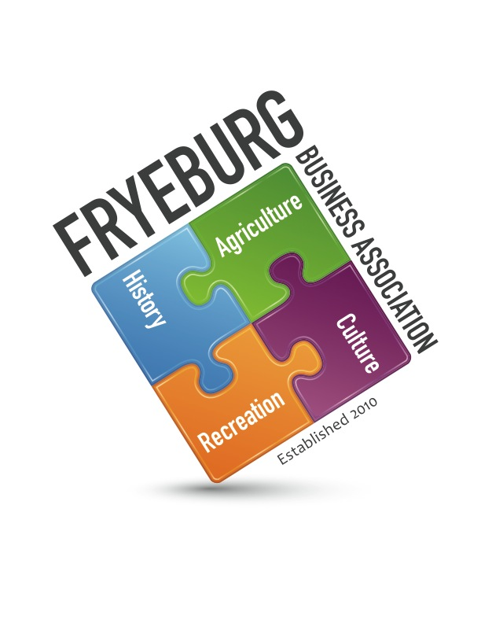
Admiral Peary Inn B & B

Wanda Richard Donna Pearce Bonnie Gould David Chaffee
Guests: Janice Crawford

- The meeting was called to Order and a Quorum declared at 3:30 pm.
- Adoption of agenda
- Previous general meeting minutes approved as written. Previous BOD meeting minutes approved as written.
- Treasurer Report – Bonnie Gould.
  - As of today, there is $15,087.13.
- President’s Message: “Thank you for coming. I asked Janice to come today because she has helped so many businesses. Please reflect on your participation on the board of the FBA. You either want to be her or you don’t. Either decision is okay, we need a new dedication to the association needs to be agreed upon.
- Janice has reviewed all documents from the inception of the FBA to include reviewing meeting minutes. In the beginning, there were good intentions with setting out for the local business. Then people started coming to the association and board with their needs and the initial goals of the FBA have gone by the wayside.
- Ongoing Business
  - Quick-books is live
  - Quick-books invoicing will be accomplished in November 2015
- New Business
  - Review insurance policy – DNO reviews in July. We need to send list of new positions to insurance company. However, the policy covers the office held.
  - Review banking/card/Signatures at Norway Savings: Jeff McClelan has been contacted. Wanda and Bonnie need to go by bank to sign new signature cards.
  - Credit card was discussed and decided it is not necessary and therefore Bonnie will close the account and destroy documentation and card (s).
- Web update
  - Ensure current documents are on website
- Guest speakers for Membership Meetings
  - Criteria - tabled
  - Schedule - tabled
- General Meeting agenda review
- Adjourn

- Meeting was adjourned at 4:49 pm.
Respectfully,
/s/ Donna M. Pearce
Donna M. Pearce, Secretary

