FRYEBURG BUSINESS ASSOCIATION
Board of Directors Meeting
Thursday, November 13, 2014, 4pm
Poland Springs Conference Room

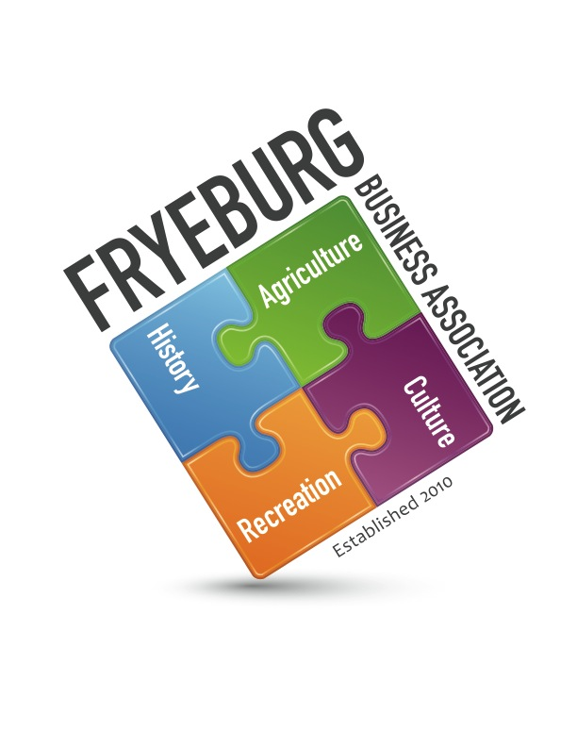
Donna Woodward – President Bonnie Gould - Treasurer
Donna Pearce – Secretary David Chaffee – Member at large
Holly Foster – Guest

- President Donna Woodward called the meeting to Order at 4:10 pm. Minutes from the membership meeting dated September 4, 2014 were unanimously approved as written
- Treasurer Report: Bonnie Gould reported the current balance of account is $12,847.39 with no outstanding bills.
  - Quick-books status – All information is updated in the Quick-books programs, however, Bonnie’s computer crashed and data is not currently accessible.
  - Quick-books invoicing will be accomplished manually with invoices being mailed to business owners. Envelopes will be prepped for mailing on December 1 @ 4 pm.
- Membership Update. Some businesses have commented they have not received emails. David and Donna will scrub the membership contact list. An email will be sent to each member asking they acknowledge receipt.
- Web update - Donna W. reported the website upkeep is quick simple and any questions are readily answered by Eric of Krack Media.
- Business/Student Mentoring Program – Donna and Holly reported numerous outstanding happenings. The mentoring program has evolved under the Economic Development program.
- Economic Development
  - Education leaders within the community saw the need for additional meetings to continue sharing information and brainstorming. Janice Crawford will be hosting the educators’ meeting to brainstorm how to share services, what classes are needed for student growth, e.g., course in truck driving. To determine what the educational leaders see their position as.
    - Work Ready Program began October 20, 2014. Fryeburg had four attendees attend. Local businesses stepped in to assist attendees with gas and transportation.
  - Fryeburg business leaders will meet December 1 to determine future steps for building Fryeburg.
  - After the education and business leaders’ meetings, information will be compiled, analyzed, best practices gleaned, and next steps determined.
- Mission Statement reviewed: Removed from agenda since the board member requesting conversation is not present.
- Discussion of nominations and procedures
  - President – Wanda Richard-Cox
  - Vice President – David Chaffee
  - Treasurer – Bonnie Gould
  - Secretary – Donna Pearce
  - Member-at-large – Donna Woodward
  - Any member in good standing of the Fryeburg Business Association is eligible to hold office. Nominations for board of director officers will be taken during the November meeting and appointed members will take seats In January.
- Guest speakers: Removed from agenda since the board member requesting the conversation is not present.
- Review board members contact information
- General Meeting agenda reviewed
- 2015 Calendar reviewed
- a. Bridgton Chamber of Commerce annual dinner to be held on November 21, 5:30 pm, at Shawnee Peak, has extended an invitation to their dinner. With a unanimous vote, it was approved to sponsor two tickets to be purchased for $45.00 each to the dinner. The executive board members decided it would be a nice measure for all of us to attend the dinner. The $90 will be put towards the purchase of four tickets.
- Meeting adjourned at 5:35 pm.
Respectfully,
/s/ Donna M. Pearce
Donna M. Pearce, Secretary

