FRYEBURG BUSINESS ASSOCIATION
GENERAL MEETING
February 10, 2015, 5:30 PM
FRYEBURG FAIRGROUNDS CONFERENCE ROOM
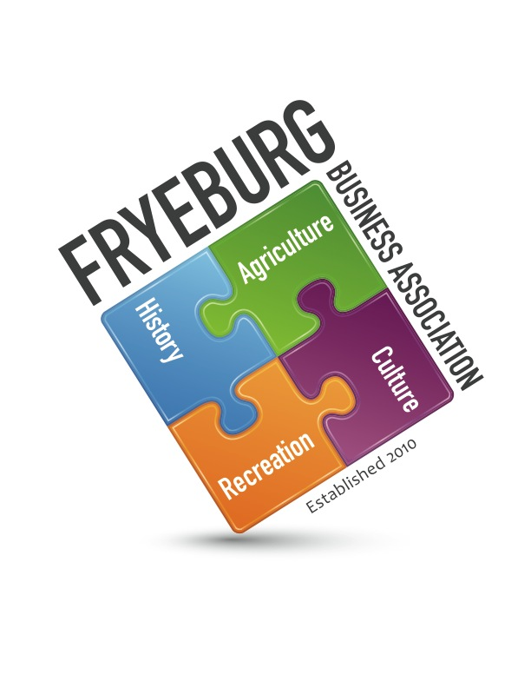

- President Wanda Richard called the meeting to order at 5:30. With the recent changes to the by-laws, the members present constituted a quorum for all voting purposes. A brief explanation of changes was given to members present.
- New Business:
  - Piggy Bank cause of the year program was suggested so members know where the money is going up front and possibly contribute more readily. The Sunshine Back Pack Food Program was nominated and approved with unanimous vote to be the charitable contribution for 2015. Wanda will talk with Chris Gillespie in reference to the criteria for children to receive a backpack.
  - It was discussed and approved to provide a place on the bottom of the invoice to enable a charitable contribution as well as on pay-pal.
  - Will also have Chris Gillespie provide information to be placed on our website so the program may be able to receive additional charitable contributions.
- The general meeting minutes for January 13, 2015 were approved as written.
- The financial report ending January 31, 2015 was approved as presented.
  - Currently balance is $13,902.13, one check outstanding for $50.00. The Mulford fund has donated $1200.00 to the Bradley Park concert series.
- On-going Business:
  - All committee chairs were asked to schedule a meeting with committee members. Chairs are to present to the board at the next general meeting their plan of action.
  - Web Update – Tabled.
  - Business2Student Mentoring Program – Deb Delmonico is the new guidance counselor. Wanda will schedule of meeting. Internship has numerous liabilities if the FBA gets involved. The FBA can facilitate only.
  - Membership Committee
    - Per Bonnie Gould and Holly Foster. Currently there are 113 members of the FBA. There were five non-renewals. Still have 43 members outstanding with their renewal.
    - Suggested to put the top few accomplishments of the FBA on the registration / renewal forms.
  - Economic Development Committee. Holly Foster reported the committee’s break is over and meetings will reconvene.
- Communications
  - Mount Washington Valley Chamber of Commerce - Tabled. Need a liaison. However, Janice Crawford talked about benefits of MWVCC.
    - Mtwashingtonvalley.org
    - Insurance? For FBA
    - 7000 rooms available in MWV
    - February 24 is afterhours at Hobbs Brewery
  - b. Greater Bridgton Area Chamber of Commerce’s – Bonnie Gould reported from the chamber chatter the Winter carnival is February 13-14-15, 2015.
- Next board of director’s meeting is scheduled for March 5, 2015, 4 pm, at the Admiral Peary Inn.
- The next general membership meeting is schedule for March 10, 2015, 5:30 pm to be held in the Fairgrounds conference room.
- Public comment. In an attempt to revitalize FBA:
  - Discussed with general membership the BOD’s suggestion of an online and email questionnaire about what would bring value to the FBA for the businesses. It was strongly suggested NOT to do this. The FBA has a mission. The organization has done a lot. A list of what those achievements are in conjunction with the mission statements will be developed. It was also discussed that some things have not been accomplished due to beliefs and political point of view of the opposition. Members need to come to meetings and generate ideas.
  - FBA only has 115 likes on Facebook. Each business was encouraged to like the FBA homepage and to share it with friends.
  - Suggested to be able to see how many people have gone on the FBA website.
  - Numerous discrepancies were found on the FBA website. The updates have been sent to Donna Woodward for officers, committee members and by-laws.
  - A discrepancy between our “tag” line and the four statements in our by-laws of our mission were noted. The BOD will review prior to the next general meeting. It was brought to the meetings attention that the operational guidelines were implemented in 2010 to provide additional guidelines.
  - It was suggested the Land use ordinates are in direct opposition of the FBA’s mission.
    - Attend planning board meetings
    - February 24 is next planning board meeting. Open to the general public
    - Next step is public hearing in June
  - Janice Crawford discussed the reciprocal snowmobile registration. A New England Pass was mentioned for Vermont, New Hampshire and Maine. With the amount of money that each state stands to lose (millions), the New England Pass will probably not come to fruition. Have more reciprocal weekends.
  - Janice Crawford would like to be on the marketing committee.
  - Janice Crawford discussed the Collaborative, Housing Authority, Economic Council and how FBA could be involved.
  - POC from fair wants and economic impact study of the fair. Fair is non-profit. Janice Crawford will aide in finding information. 2014 included guests from all 50 states and 17 countries.
- Meeting adjourned at 7:30 pm

Respectfully,

/s/ Donna M. Pearce

Donna M. Pearce, Secretary

